Capabilities Statement

#### Company Overview

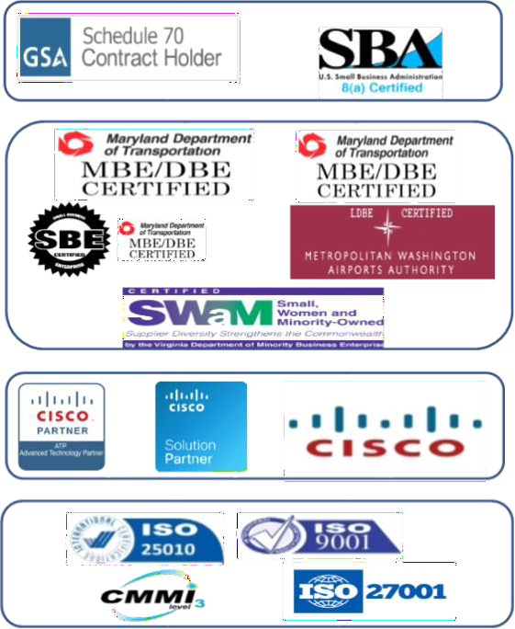

***Technuf is a Maryland-based Information Technology company driven by innovation and excellence. We harness the knowledge and expertise of our highly skilled and motivated team of professionals to help our clients meet their mission-critical business needs. Providing a combination of leading-edge proven technologies, and industry vertical domain expertise, our team enables our clients to thrive on change. We offer a partnership based on knowledge sharing and skill transfer.***

#### Company Data

**DUNS:** 078788966

**CAGE:** 74VG8

**NAICS:** [541511] [541512] [541513] [541519] [541611]

***Certifications***

*FEDERAL*

*STATE*

*COMMERCIAL*

*GLOBAL*

***Past Performance/Client***

## Services

### Cybersecurity

*We offer a comprehensive approach toward cybersecurity that allows us to deliver the highest level of information assurance and data protection, ensuring compliance to government and industry standards.*

### Business Intelligence

*Our in-house team of experts use a set of proven methodologies (i.e ETL) to develop optimized business intelligence, and data analytics applications with custom and on-demand reporting.*

### Software Engineering / App Dev (Mobile, IoT, AI & ML)

*We use component-based architecture with Agile & iterative methodology to develop mission critical and secure applications.*

### Management Approach

*Our management approach leverages industry best practices and existing customer relationships to improve the quality of delivery on time & budget. We stay on-top of emerging and disruptive technologies (Cloud, IOT, AI, ML, Blockchain)*

## Products

**Aphelia Collaboration System** *Aphelia is a highly scalable and reliable mobile interface that integrate cellphones, WiFi, and radio technologies to provide collaboration across organizations.*

#### Health Connect

*A centralized automated system for health care professionals to enhance productivity, improve accuracy and promote efficiency.*



***Core Capabilities***

# Cybersecurity

 Intrusion Detection (IDS)  Intrusion Prevention (IPS)  Penetration Testing

 Vulnerability Assessment

 Security Operations Center (SOC)  Governance and Compliance

 Security Audit - PCI, SAS, NIST  Forensic Analysis and eDiscovery  Data Loss Prevention (DLP)

 Privileged Access Management (PAM)

 Authentication/Authorization Single Sign-on (SSO)

 Role Based Access Control (RBAC)  Deep Packet Capture

 Insider Threat Detection/Prevention  Advanced Persistent Threat (APT)  Cyber Threat Intelligence (CTI)

 Secure communications

 Certification & Accreditation

 Risk Assessment & Security Planning  Cybersecurity Training

 Identity and Access Management (IdAM)

# Software Engineering and IoT

 Business and requirements analysis  Architecture management

 Detailed design, implementation, and integration

 Multi-tiered architecture with mobile clients

 Complex real-time incidence response systems

 Safety critical applications  Real-time solutions

 Fault-redundant systems  Mission critical applications  Functionality Testing

 Performance Testing

 Usability and Accessibility (508)  Customer Acceptance Testing

**CMMI Appraisal**

 Our in-house team of qualified High Maturity Assessment Team Members (ATMs) conduct CMMI certifications with Third Party partner company,

# Business Intelligence

 Interface with unstructured data  QlikView Business Discovery

platform & ETL

 Denormalization, Tagging & Standardization

 Data Warehousing Adapters  Data Mining

 Advanced Analytics  Statistical Inference

 Real-time reporting & Alerts

# Transportation Tracking System

 Child Attendance, Safety and Tracking

 Dispatch and Collaboration System

 Emergency Alert Response System

 Referral Management Method

# Management Approach

 SDLC and Agile Management  PMBOK-based best practices  Requirements management  Resource management

 Communications Risk Management

 Change Management  Training

 Asset Management  Scheduling

 Budget and status monitoring + reporting

# Health Connect

 Centralized automated system for health care professionals

 EMedNY Integration  Offline Mode

 Quick Assessment

 Medicaid ID Validation  Calendar Notification



**40 W. Gude Dr, Suite 220 Rockville MD – 20850** [**www.technuf.com**](http://www.technuf.com/)[**info@technuf.com**](mailto:info@technuf.com)